**Tip: Getting Started on Closing Arguments**

- If you are seeking training on permissible and impermissible arguments, JAJG hosts the Argument Handbook<https://cs3.eis.af.mil/sites/afjagc/AFLOA/JAJ/JAJG/field/How%20To%20Case%20Primers/Forms/AllItems.aspx>.

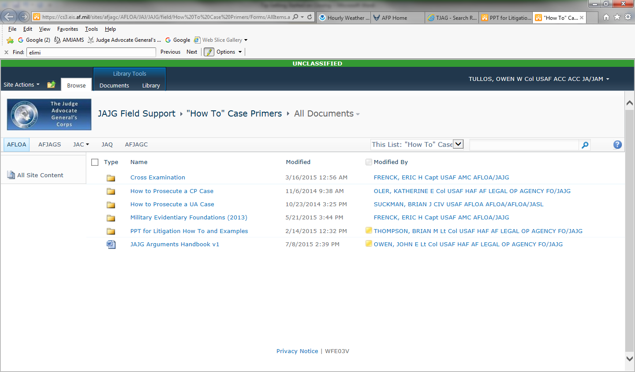

- There is also training in the [Ancillary Training Subfolder](Ancillary%20Training%20Documents)

- Remember to argue in closing: Don’t just re-present facts as in opening, draw conclusions demonstrating why the evidence is strong and prove the elements beyond a reasonable doubt